Angle Bisector Theorem

Definition
# Source: AI Source: Provided by: [Data Path: Persons Table -> ID Column: 1, Name_En Column: Motasem Essam] -> From: [ChatGPT] on [7/25/2026]
The Angle Bisector Theorem states that an angle bisector of a triangle divides the opposite side into two segments proportional to the adjacent sides.
Consider triangle $ABC$. If $AD$ bisects $∠A$ and meets $BC$ at $D$, then:
$$\boxed{\frac{BD}{DC}=\frac{AB}{AC}}$$
In other words, the angle bisector divides the opposite side in the same ratio as the two sides forming the angle.
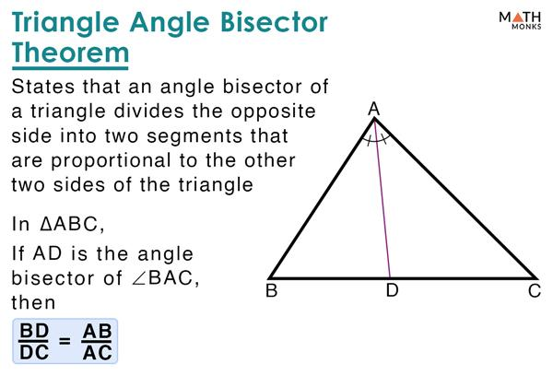
​
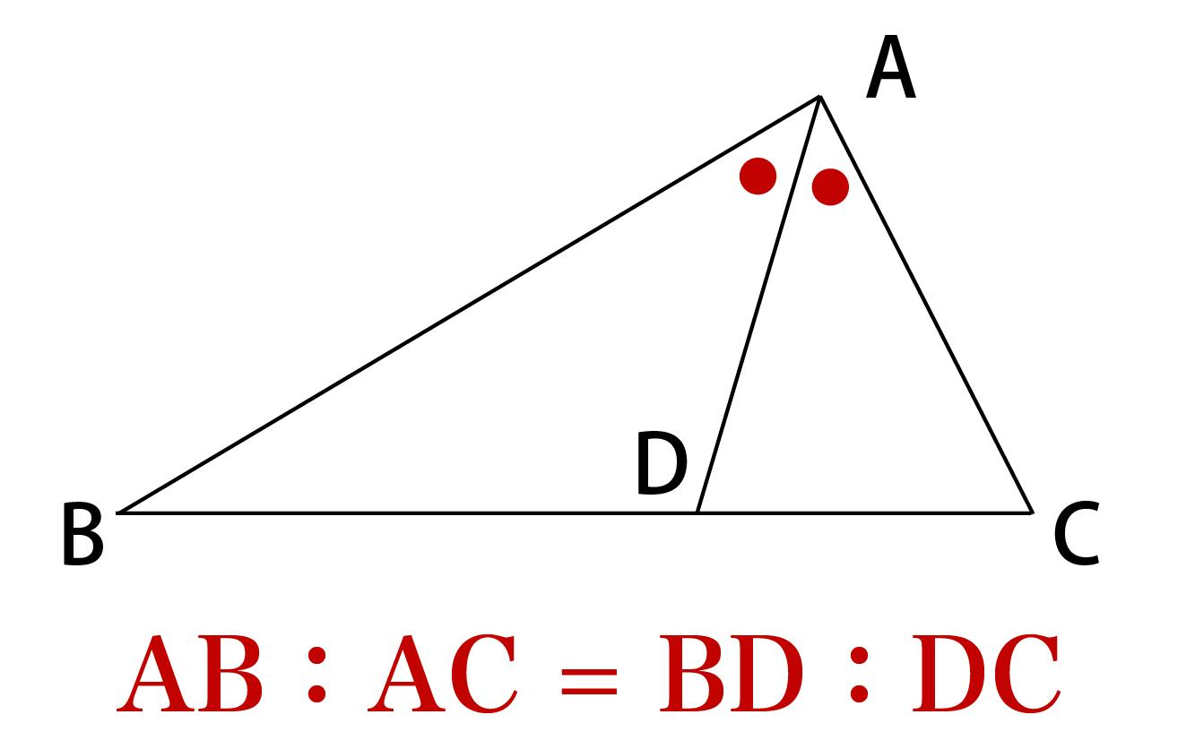
​
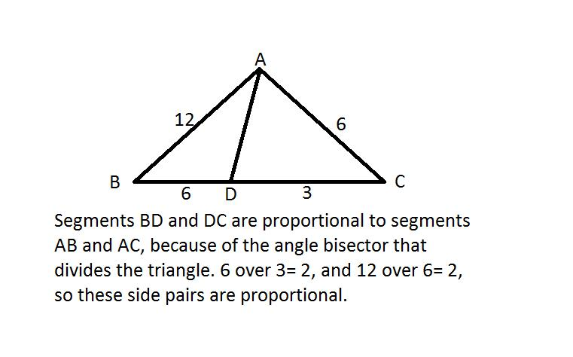
​
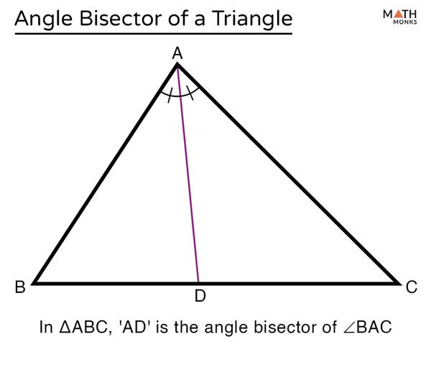

Purpose
# Source: AI Source: Provided by: [Data Path: Persons Table -> ID Column: 1, Name_En Column: Motasem Essam] -> From: [ChatGPT] on [7/25/2026]
The Angle Bisector Theorem is used to:
- Find unknown side segments.
- Determine the position where an angle bisector meets the opposite side.
- Establish proportional relationships.
- Solve triangle geometry problems.
- Support geometric proofs.
- Connect angle relationships with side lengths.

Basic Configuration
# Source: AI Source: Provided by: [Data Path: Persons Table -> ID Column: 1, Name_En Column: Motasem Essam] -> From: [ChatGPT] on [7/25/2026]
Consider triangle $ABC$.
Draw the angle bisector $AD$ from vertex $A$ to side $BC$.
Then:
$$∠BAD=∠DAC$$
Since $AD$ is an angle bisector.
The opposite side $BC$ is divided into:
$$BD$$
and:
$$DC$$
The theorem states:
$$\boxed{\frac{BD}{DC}=\frac{AB}{AC}}$$
​
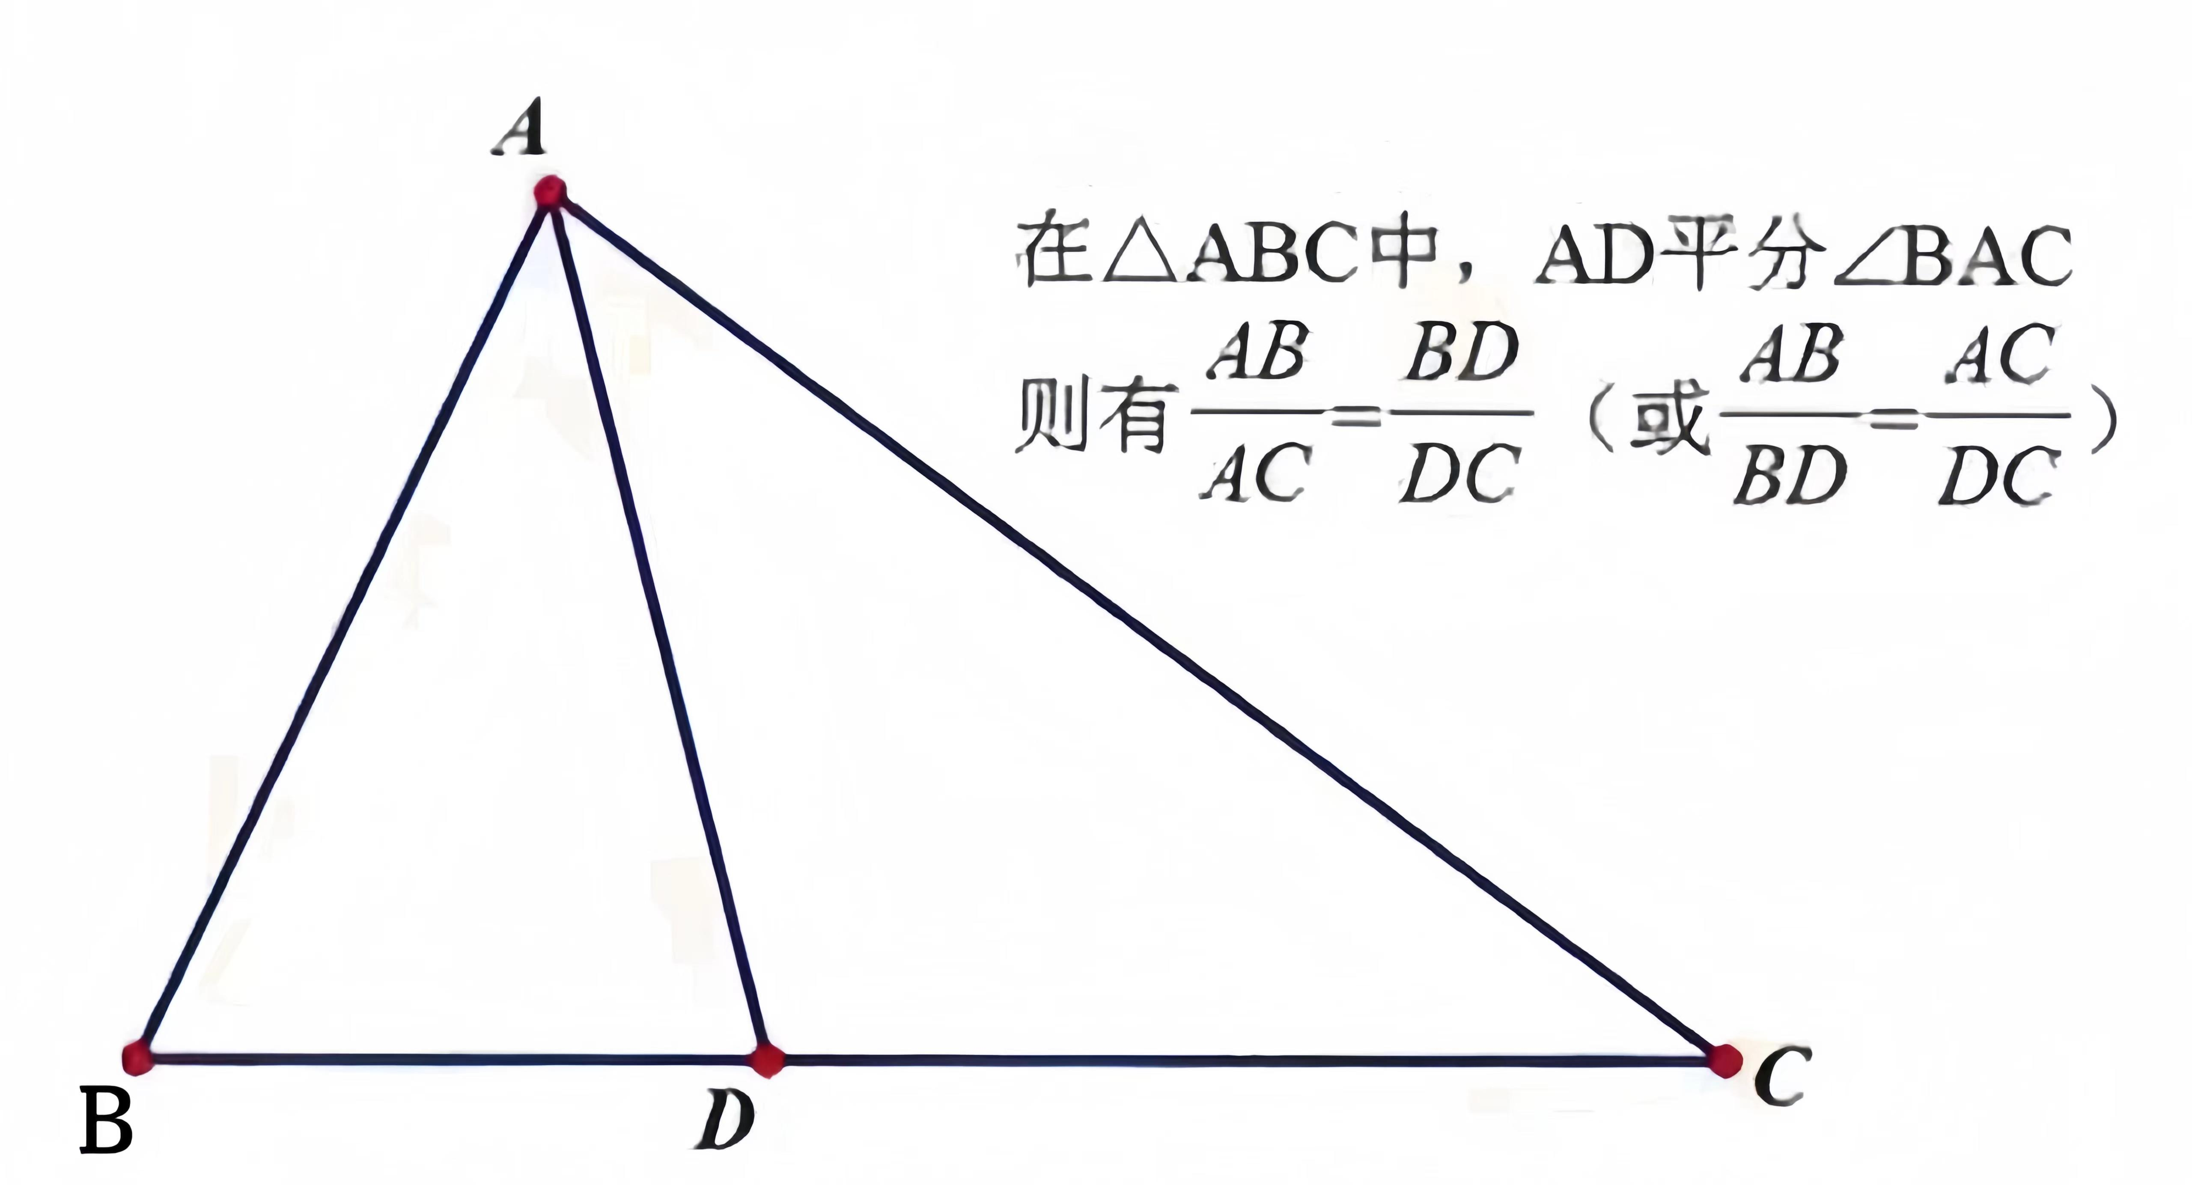
​
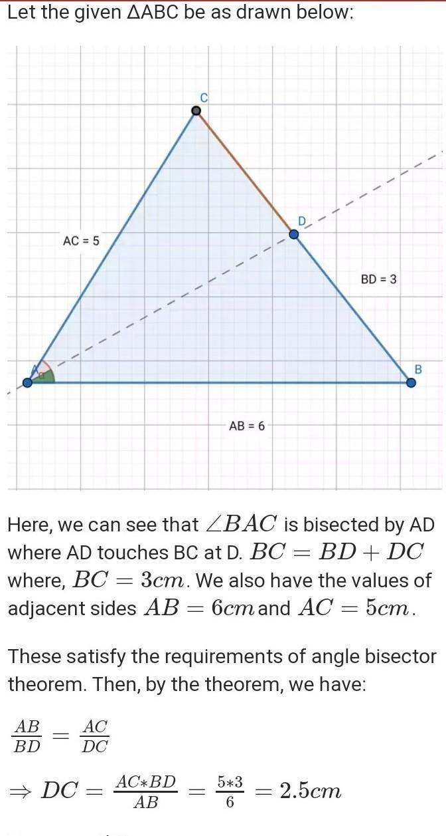
​
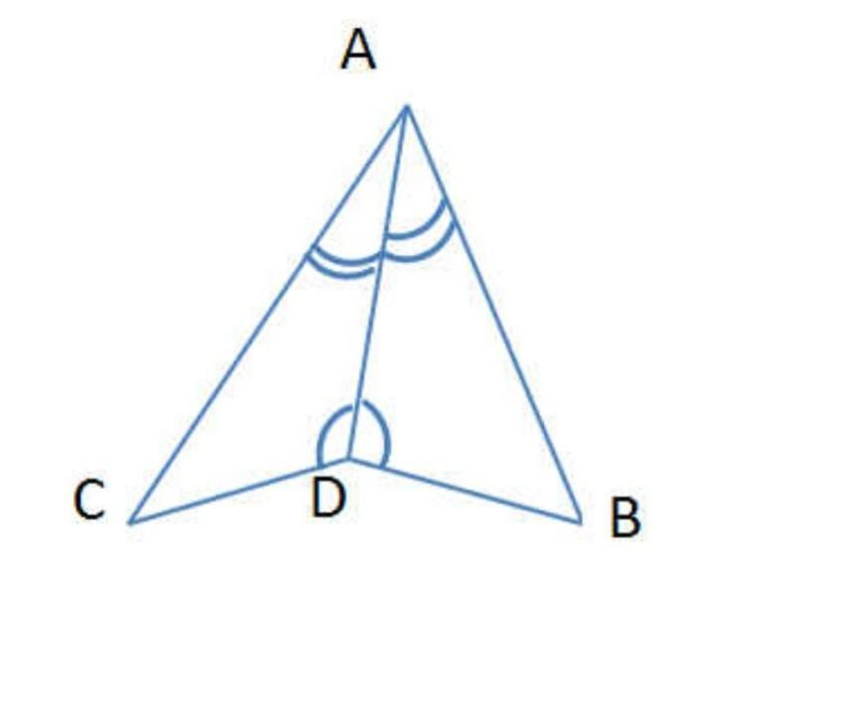

Mathematical Representation
# Source: AI Source: Provided by: [Data Path: Persons Table -> ID Column: 1, Name_En Column: Motasem Essam] -> From: [ChatGPT] on [7/25/2026]
If:
$$\boxed{∠BAD=∠DAC}$$
then:
$$\boxed{\frac{BD}{DC}=\frac{AB}{AC}}$$
This means:
$$\boxed{BD:DC=AB:AC}$$

Example 1 — Finding an Unknown Segment
# Source: AI Source: Provided by: [Data Path: Persons Table -> ID Column: 1, Name_En Column: Motasem Essam] -> From: [ChatGPT] on [7/25/2026]
Suppose:
$$AB=6$$
$$AC=9$$
and:
$$BD=4$$
Find $DC$.
Using the Angle Bisector Theorem:
$$\frac{BD}{DC}=\frac{AB}{AC}$$
Substitute:
$$\frac{4}{DC}=\frac{6}{9}$$
Simplify:
$$\frac{4}{DC}=\frac{2}{3}$$
Cross-multiply:
$$2DC=12$$
Therefore:
$$\boxed{DC=6}$$
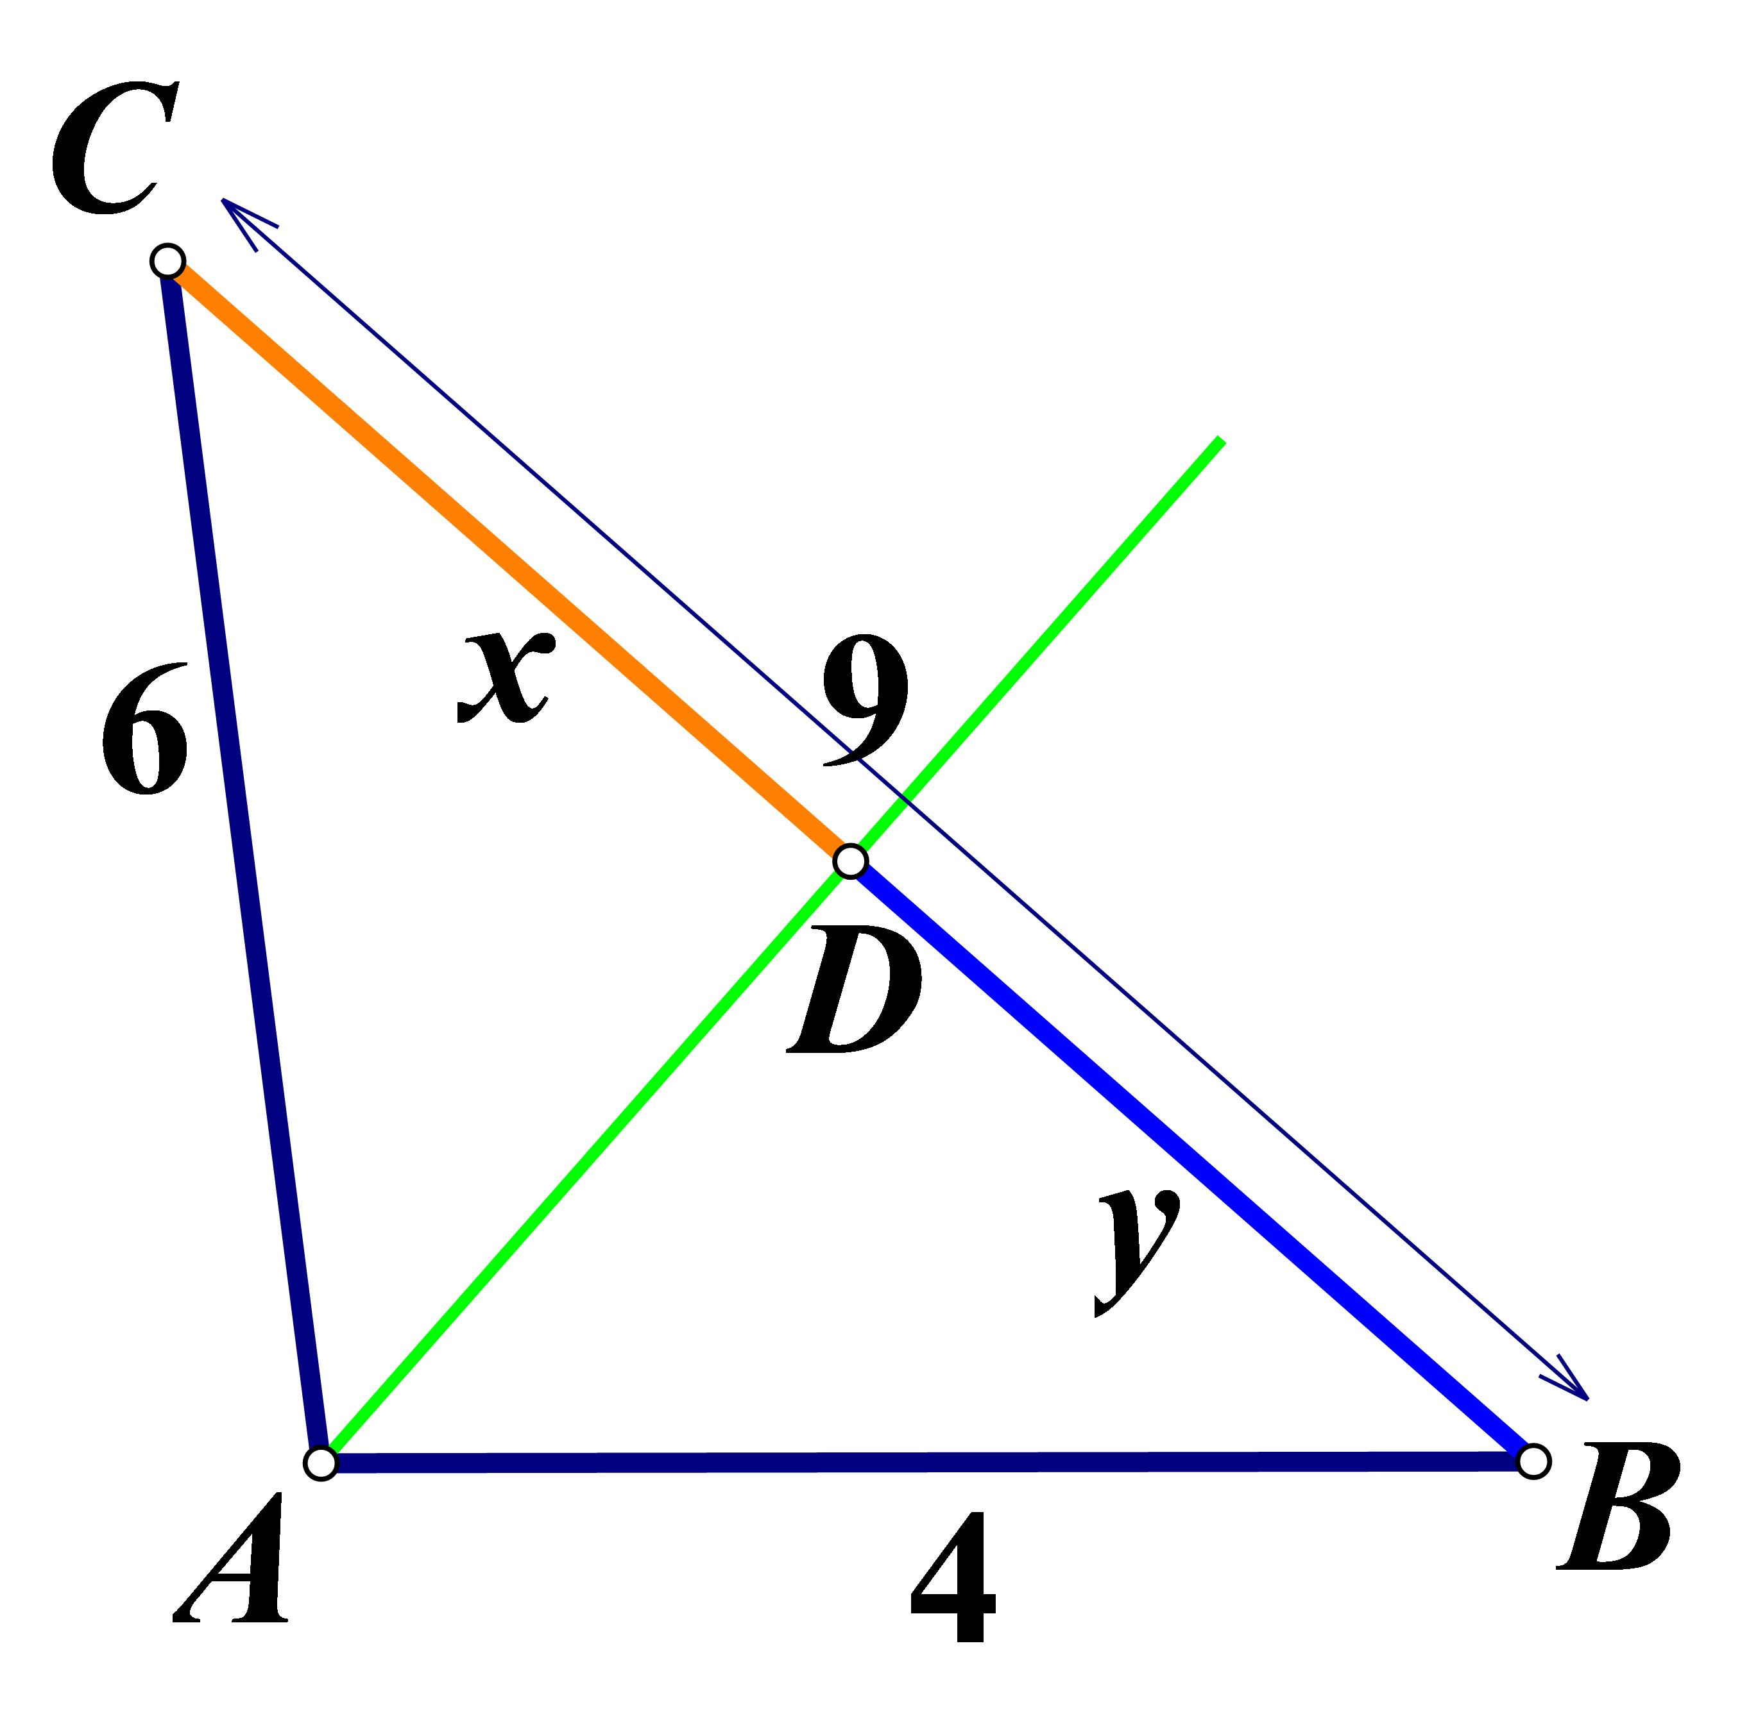
​
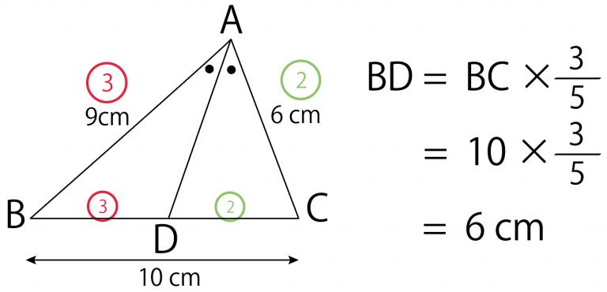​
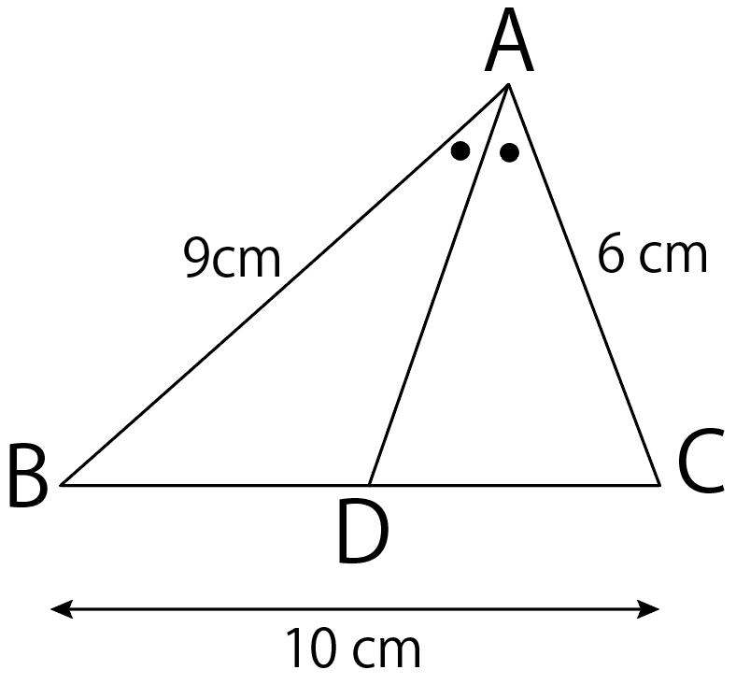

Example 2 — Finding a Side Segment
# Source: AI Source: Provided by: [Data Path: Persons Table -> ID Column: 1, Name_En Column: Motasem Essam] -> From: [ChatGPT] on [7/25/2026]
Suppose:
$$AB=10$$
$$AC=15$$
and:
$$BC=20$$
Find $BD$ and $DC$.
From the theorem:
$$\frac{BD}{DC}=\frac{10}{15}$$
Simplify:
$$\frac{BD}{DC}=\frac{2}{3}$$
Therefore, the side $BC$ is divided in the ratio:
$$BD:DC=2:3$$
The total number of ratio parts is:
$$2+3=5$$
Each part is:
$$\frac{20}{5}=4$$
Therefore:
$$\boxed{BD=8}$$
and:
$$\boxed{DC=12}$$

Example 3 — Equal Sides
# Source: AI Source: Provided by: [Data Path: Persons Table -> ID Column: 1, Name_En Column: Motasem Essam] -> From: [ChatGPT] on [7/25/2026]
Suppose:
$$AB=AC$$
Then:
$$\frac{BD}{DC}=\frac{AB}{AC}$$
Since:
$$\frac{AB}{AC}=1$$
we get:
$$\frac{BD}{DC}=1$$
Therefore:
$$\boxed{BD=DC}$$
So, in an isosceles triangle, the angle bisector from the vertex angle also bisects the base.
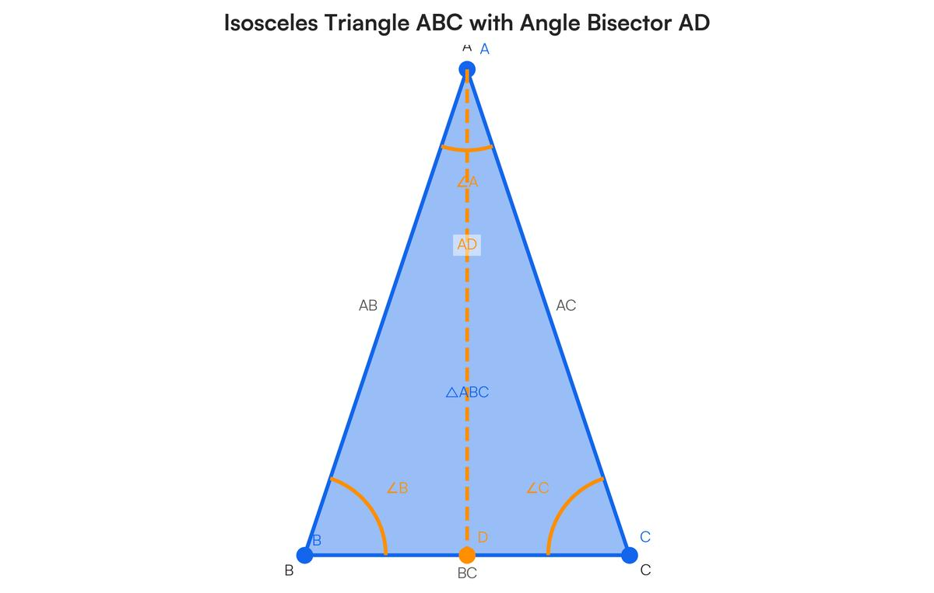
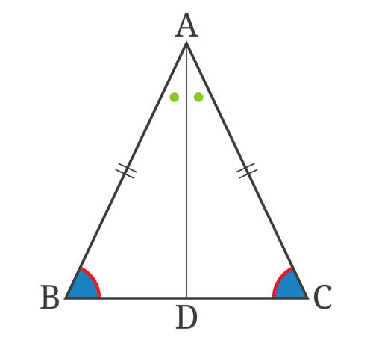
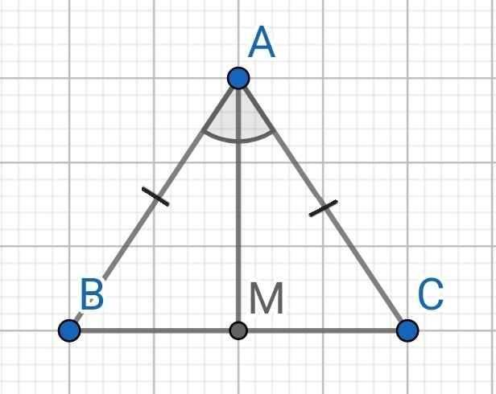
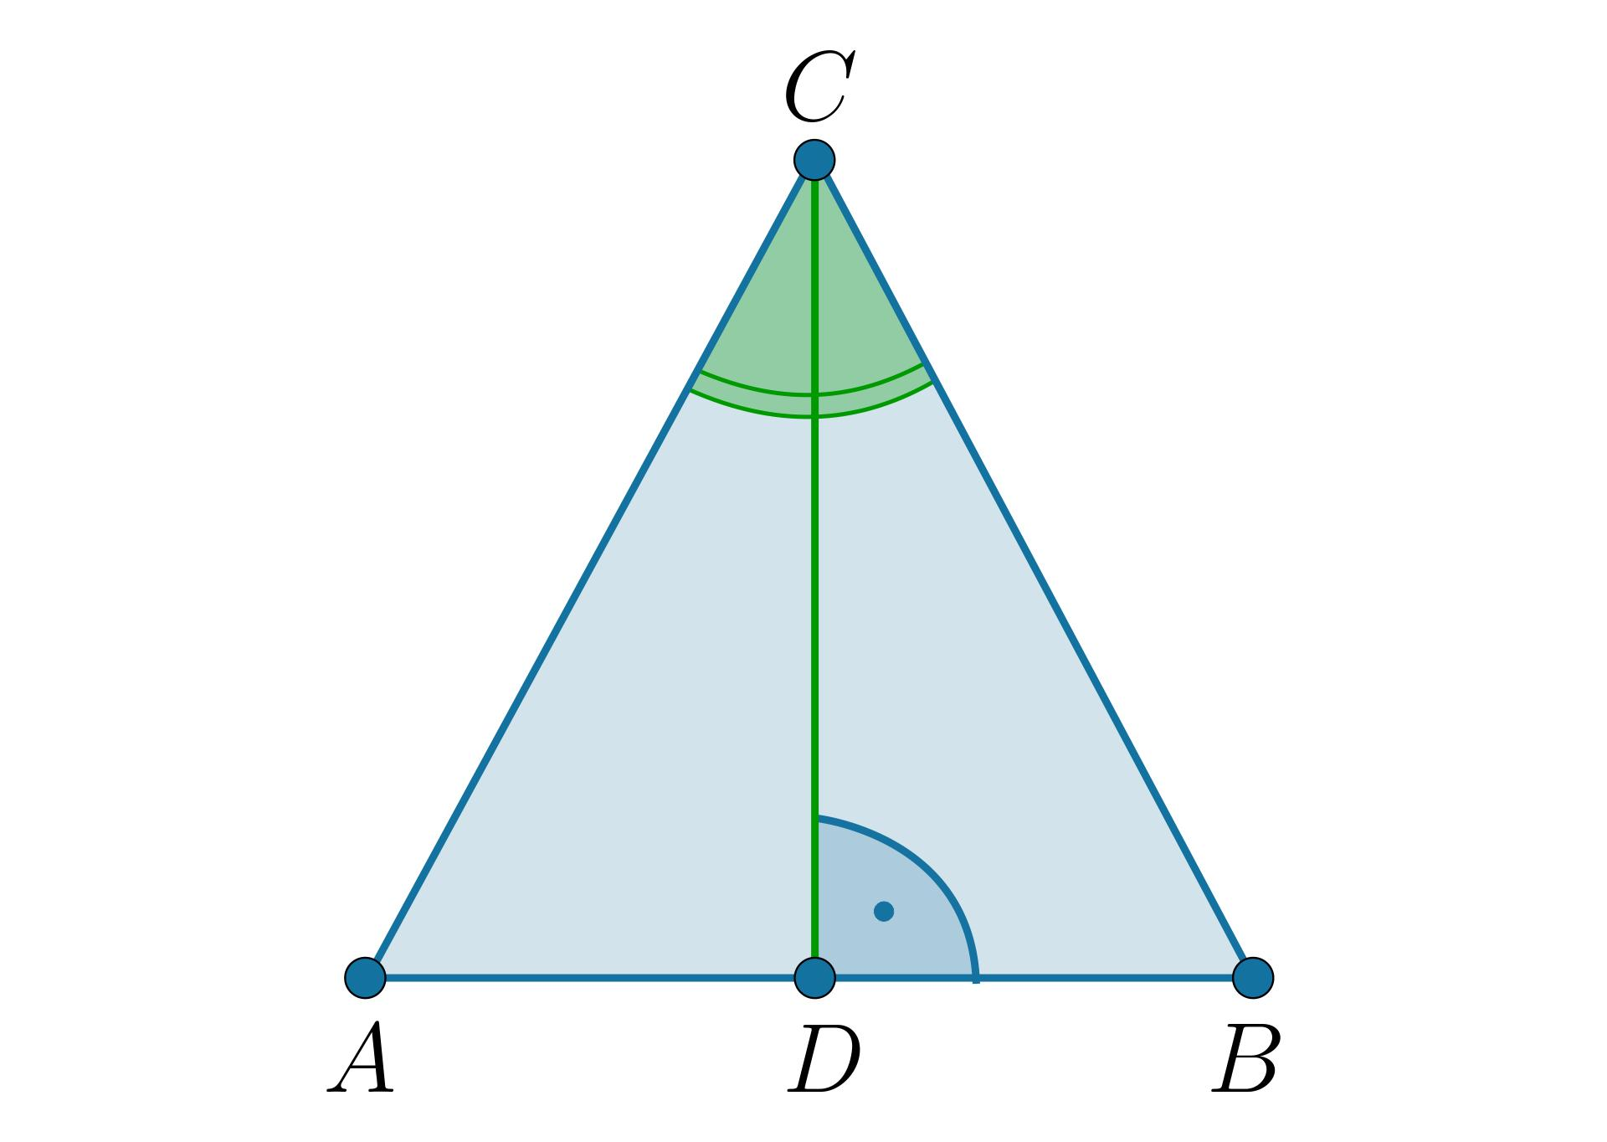

Converse of the Angle Bisector Theorem
# Source: AI Source: Provided by: [Data Path: Persons Table -> ID Column: 1, Name_En Column: Motasem Essam] -> From: [ChatGPT] on [7/25/2026]
The theorem also has a converse.
If a point $D$ on $BC$ divides the opposite side proportionally:
$$\boxed{\frac{BD}{DC}=\frac{AB}{AC}}$$
then $AD$ bisects $∠A$.
Therefore:
$$\boxed{\frac{BD}{DC}=\frac{AB}{AC}⇒∠BAD=∠DAC}$$
This allows us to prove that a line is an angle bisector.

Proof Idea
# Source: AI Source: Provided by: [Data Path: Persons Table -> ID Column: 1, Name_En Column: Motasem Essam] -> From: [ChatGPT] on [7/25/2026]
The proof of the Angle Bisector Theorem is based on similarity or area relationships.
Suppose:
$$AD$$
bisects $∠A$.
The two triangles:
$$△ABD$$
and:
$$△ACD$$
have equal altitudes from $A$ to $BC$.
Therefore, their areas are proportional to their bases:
$$\frac{[ABD]}{[ACD]}=\frac{BD}{DC}$$
Using the area formula:
$$[ABD]=\frac{1}{2}(AB)(AD)sin∠BAD$$
and:
$$[ACD]=\frac{1}{2}(AC)(AD)sin∠DAC$$
Since:
$$∠BAD=∠DAC$$
their sine values are equal.
Therefore:
$$\frac{[ABD]}{[ACD]}=\frac{AB}{AC}$$
Hence:
$$\boxed{\frac{BD}{DC}=\frac{AB}{AC}}$$

Relationship with Proportionality
# Source: AI Source: Provided by: [Data Path: Persons Table -> ID Column: 1, Name_En Column: Motasem Essam] -> From: [ChatGPT] on [7/25/2026]
The Angle Bisector Theorem is a special type of proportional relationship.
It connects:
- Two sides of a triangle.
- Two segments of the opposite side.
- An angle bisector.
The fundamental relationship is:
$$\boxed{BD:DC=AB:AC}$$

Angle Bisector and Perpendicular Bisector
# Source: AI Source: Provided by: [Data Path: Persons Table -> ID Column: 1, Name_En Column: Motasem Essam] -> From: [ChatGPT] on [7/25/2026]
These concepts are different.
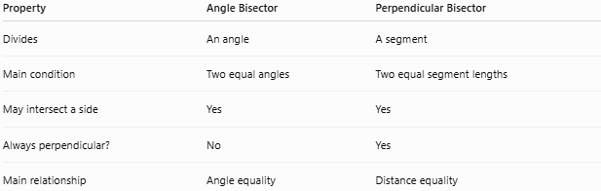
Property | Angle Bisector | Perpendicular Bisector
Divides | An angle | A segment
Main condition | Two equal angles | Two equal segment lengths
May intersect a side | Yes | Yes
Always perpendicular? | No | Yes
Main relationship | Angle equality | Distance equality
An angle bisector does not necessarily meet the opposite side at its midpoint.
It does so when the two adjacent sides are equal.

Angle Bisector in an Isosceles Triangle
# Source: AI Source: Provided by: [Data Path: Persons Table -> ID Column: 1, Name_En Column: Motasem Essam] -> From: [ChatGPT] on [7/25/2026]
For an isosceles triangle:
$$AB=AC$$
the angle bisector from $A$ divides $BC$ equally:
$$\boxed{BD=DC}$$
It also acts as:
- A median.
- An altitude.
- A perpendicular bisector of the base.
- An axis of symmetry.
Thus, several important geometric properties occur along the same line.
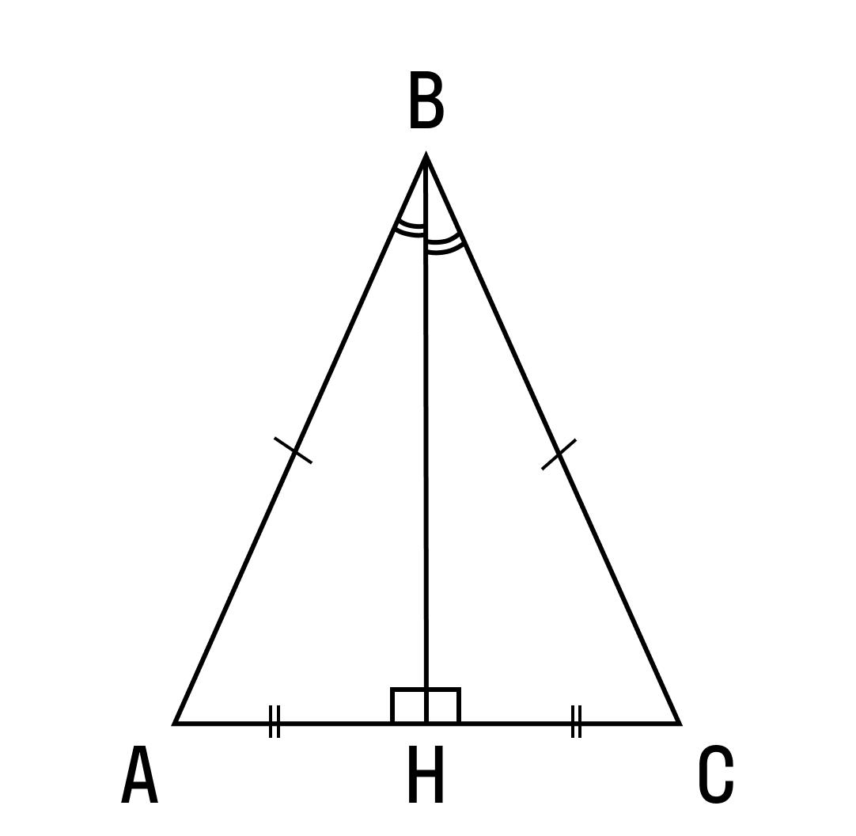​
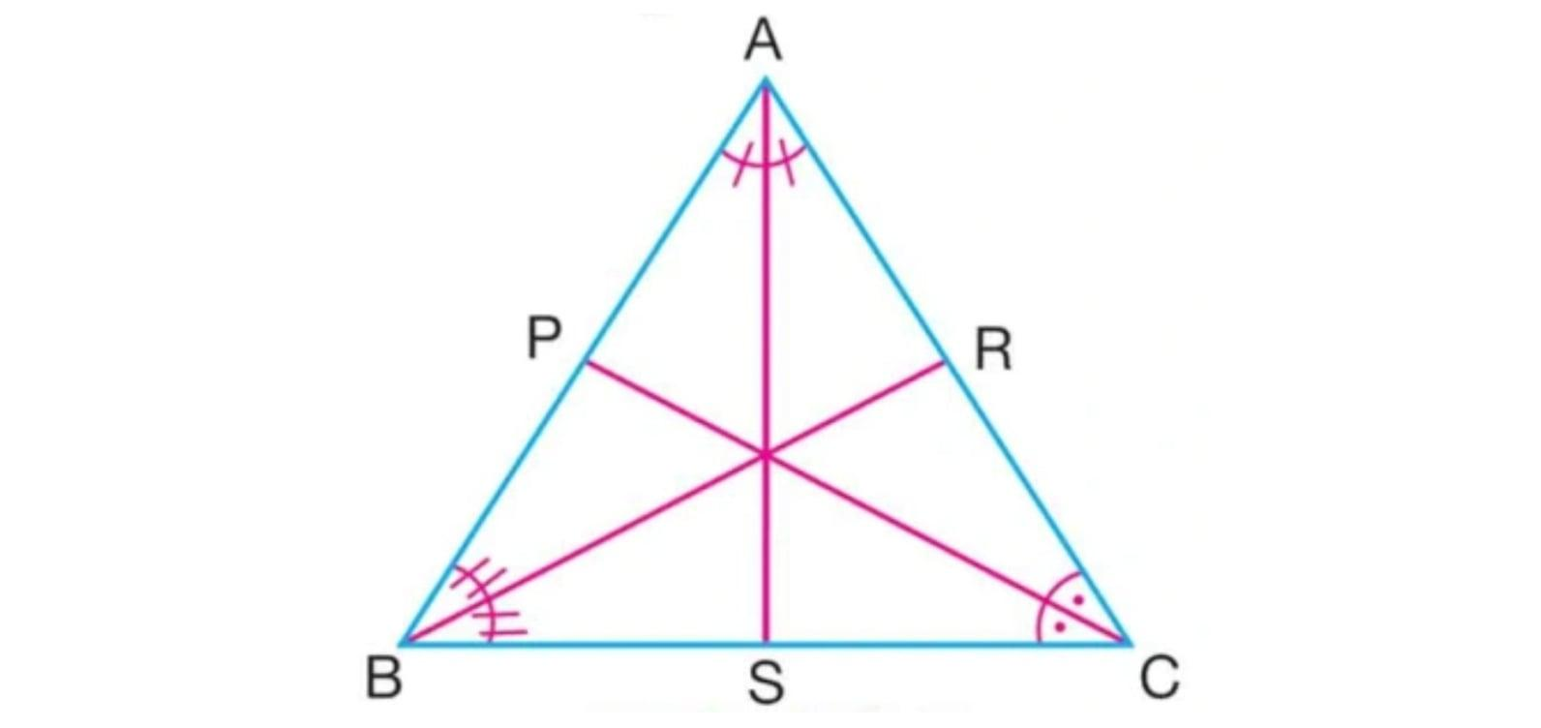
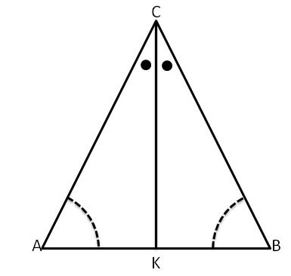

Relationship with Triangle Similarity
# Source: AI Source: Provided by: [Data Path: Persons Table -> ID Column: 1, Name_En Column: Motasem Essam] -> From: [ChatGPT] on [7/25/2026]
The Angle Bisector Theorem is closely related to triangle similarity and proportionality.
When an angle is divided into two equal angles, proportional relationships can be established between the sides and the resulting segments.
It is therefore frequently used together with:
- Similar triangles.
- Proportions.
- Congruence.
- Triangle geometry.

Real-World Applications
# Source: AI Source: Provided by: [Data Path: Persons Table -> ID Column: 1, Name_En Column: Motasem Essam] -> From: [ChatGPT] on [7/25/2026]
Angle-bisector relationships can be useful in:
- Architecture.
- Engineering.
- Construction.
- Surveying.
- CAD.
- Technical drawing.
- Computer graphics.
- Land measurement.
For example, proportional division can help determine where a line should meet the side of a triangular structure when the line must bisect an angle.
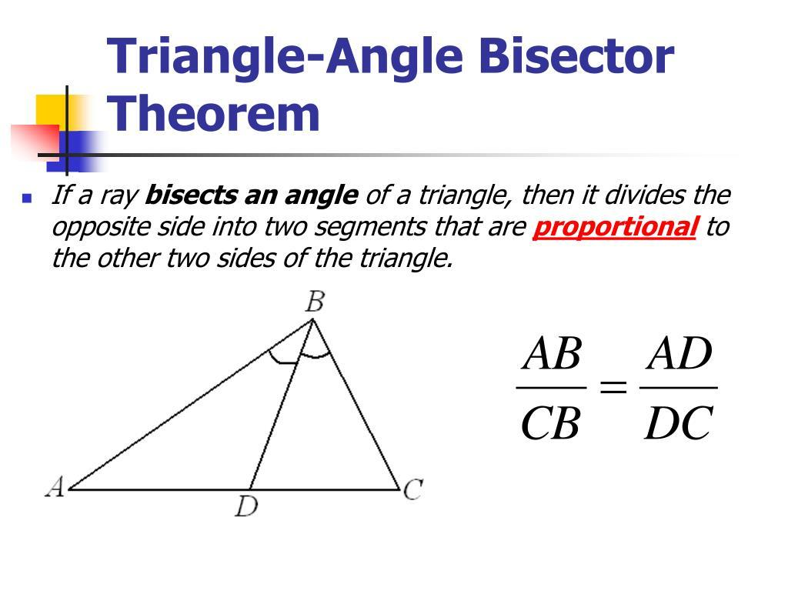
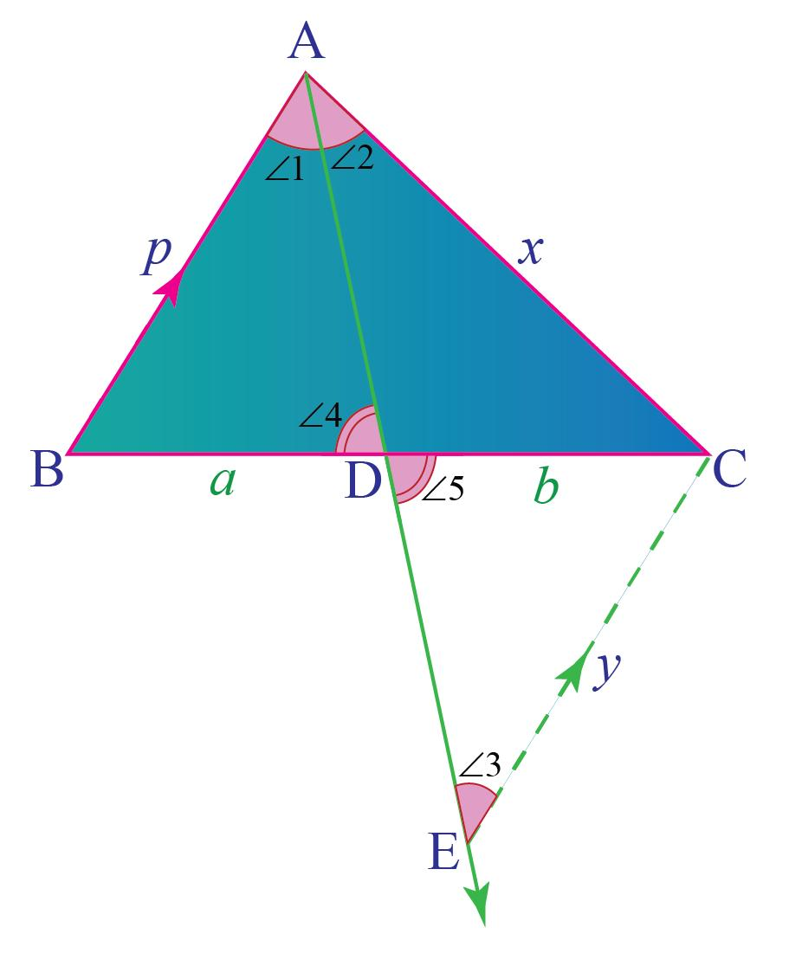
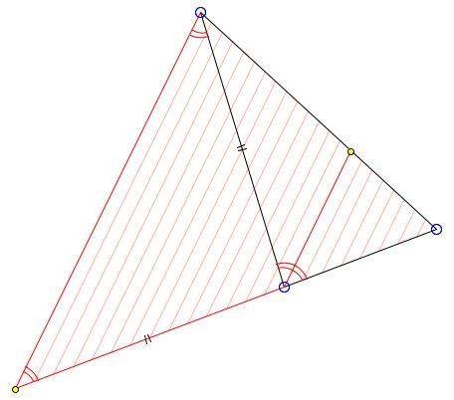

Applications
# Source: AI Source: Provided by: [Data Path: Persons Table -> ID Column: 1, Name_En Column: Motasem Essam] -> From: [ChatGPT] on [7/25/2026]
The Angle Bisector Theorem is important in:
- Plane Geometry
- Triangle Geometry
- Euclidean Geometry
- Proportionality
- Similarity
- Trigonometry
- Architecture
- Engineering
- Surveying
- CAD
- Computer Graphics

Advantages
# Source: AI Source: Provided by: [Data Path: Persons Table -> ID Column: 1, Name_En Column: Motasem Essam] -> From: [ChatGPT] on [7/25/2026]
The theorem helps to:
- Find unknown side segments.
- Solve triangle proportion problems.
- Determine the location of an angle bisector.
- Prove that a line is an angle bisector.
- Simplify geometric calculations.
- Connect angle measurements with side lengths.

Limitations
# Source: AI Source: Provided by: [Data Path: Persons Table -> ID Column: 1, Name_En Column: Motasem Essam] -> From: [ChatGPT] on [7/25/2026]
The theorem:
- Applies to triangles.
- Requires an actual angle bisector for the direct theorem.
- Requires correct identification of the two sides forming the angle.
- Uses the segments created on the opposite side.
- Does not mean that every angle bisector divides the opposite side into equal lengths.

Comparison with Related Theorems
# Source: AI Source: Provided by: [Data Path: Persons Table -> ID Column: 1, Name_En Column: Motasem Essam] -> From: [ChatGPT] on [7/25/2026]
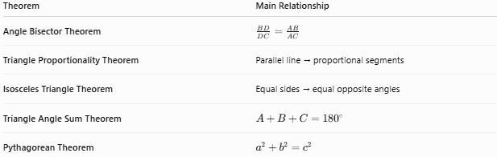
Theorem | Main Relationship
Angle Bisector Theorem | $\frac{BD}{DC}=\frac{AB}{AC}$​
Triangle Proportionality Theorem | Parallel line → proportional segments
Isosceles Triangle Theorem | Equal sides → equal opposite angles
Triangle Angle Sum Theorem | $A+B+C={180}^{∘}$​
Pythagorean Theorem | $a^{2}+b^{2}=c^{2}$​

Key Points
# Source: AI Source: Provided by: [Data Path: Persons Table -> ID Column: 1, Name_En Column: Motasem Essam] -> From: [ChatGPT] on [7/25/2026]
- An angle bisector divides an angle into two equal angles.
- In triangle $ABC$, if $AD$ bisects $∠A$:
$$\boxed{∠BAD=∠DAC}$$
- The Angle Bisector Theorem states:
$$\boxed{\frac{BD}{DC}=\frac{AB}{AC}}$$
- The opposite side is divided in the same ratio as the two adjacent sides.
- If $AB=AC$, then:
$$\boxed{BD=DC}$$
- The converse can be used to prove that a line is an angle bisector.
- The theorem is an important application of proportionality in triangle geometry.

Conclusion
# Source: AI Source: Provided by: [Data Path: Persons Table -> ID Column: 1, Name_En Column: Motasem Essam] -> From: [ChatGPT] on [7/25/2026]
The Angle Bisector Theorem establishes a proportional relationship between the two sides of a triangle and the two segments created on the opposite side by an angle bisector. If $AD$ bisects $∠A$ in triangle $ABC$, then:
$$\boxed{\frac{BD}{DC}=\frac{AB}{AC}}$$
This theorem provides an efficient method for finding unknown lengths and proving geometric relationships. It is closely connected to proportionality, triangle similarity, isosceles triangles, and geometric constructions, making it an important theorem in plane geometry.

